

|  |  |  |  |  |  |  |  |  |
| --- | --- | --- | --- | --- | --- | --- | --- | --- |
|  | | | | | | | | |
|  | | Sequence Diagrams | | | | |  | |
|  |  | | | | | | |  |
|  | | | |  | |  | | |
|  | | | | Muhammad Talha(Lead)Zohaib ZafarAbdul RehmanGroup 12 | |  | | |
|  | | | | Date24 March 2025Course titleSoftware ConstructionTeacher’s NameDr. Onaiza Maqbool | |  | | |
|  | | |  | |  | | | |

**Name: Zohaib Zafar**

**Reg. No: 04072312049**

**System Sequence Diagram**

**(Request for software installation)**

The Request for Software Installation use case allows Students and Teachers to request software installations on laboratory computers. The user submits a request through the interface, specifying the software and computer details. The system saves the request to the database and notifies the Manager for approval. Once submitted, the request status is updated, ensuring a streamlined process for software installation requests.

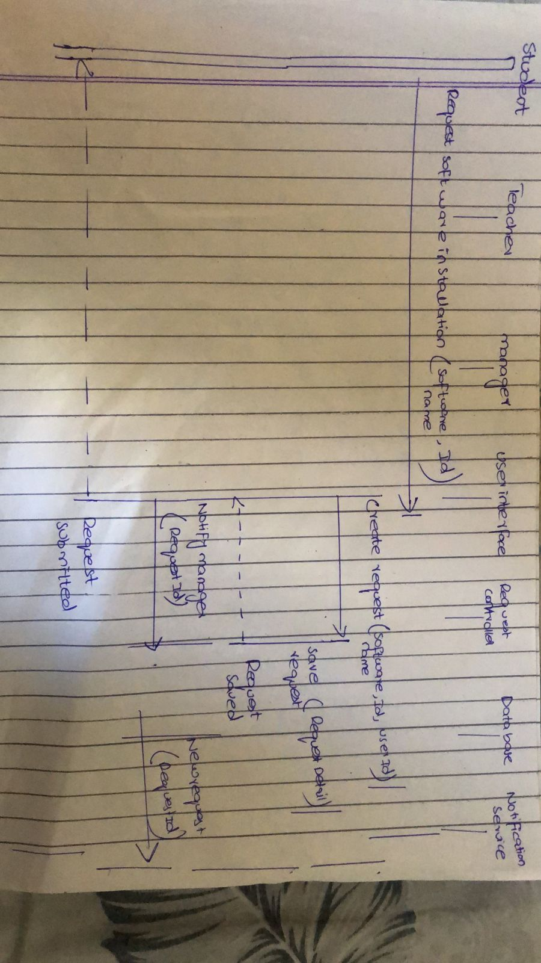

**System Sequence Diagram**

**(Approved software installation Request)**

The Approved Software Installation Request use case involves the Manager reviewing and approving software installation requests. The Manager updates the request status to "Approved," and the system notifies the user. The approved software is then installed on the specified computer, and the system updates the software list. This ensures efficient handling and implementation of software installation requests.

